Hi Aaron,
I look forward to the opportunity to work with you.
The thought is to have you start with a small, fixed term project that includes a one page design comp of a “celebrity height” viewer. This exercise will give you a feel for the work we require as well as to provide us an opportunity to see how well your style fits our needs and a feel for how efficiently you can turn projects around.
We have dozens of projects in the works ranging in size. We will start one project at a time. The first project fits within a simple database driven application that displays the heights of celebrities. We have the required date; we need you to design that the data will display.
Project #1: Celebrity Height Application
Summary: Each month hundreds of thousands of online searches are conducted for celebrity heights. Example searches include: “height tom cruise”, “what is the height of Jennifer Anniston”, “what is the height and weight of Mel Gibson”. The goal of this project is to create an interactive “celebrity height” application using Juggle’s internal knowledge engine. Your task is to create the design the way the celebrities’ heights are displayed within the application.
Key points & features:
- Juggle’s knowledge engine currently houses the height of every mainstream celebrity. We also have a thumbnail picture, title and short description of the celebrity and the area of business for which they are known (TV Star, Movie Star, etc).
Your task:
I have outlined a mock-up of what you will be designing. The screen shown (below) is as if someone had landed on a page answering the height of Tom Cruise. You can see from the mock-up we wish to highlight his height in text and also visually on a height chart.
We will rely on a rules engine to put on either side of him people’s heights that are related to him either from dating relationships or from people he has worked…
We wish to include a thumbnail picture in your design, the name of the celebrity and the celebrities’ height. The stick figures are to represent each celebrity on a height chart. You are tasked with the job of designing how this will look and creating images to accurately display a male and female’s height in proportion to the others.
To keep things simple we do not want to try to create individual characters that represent how each celebrity looks, instead a stock example, like the stick people, that represents whether they are male or female and that can scale up and down depending on the users height. I am not sure if that means you need to create a figure for each inch of height from say 3’00’’ – 8’00” or if there is a faster, better way.
From a look and feel perspective we would like to keep it simple – we would like to have drop shadowing to add depth.
We would like to offer you whatever creative freedom you wish, but request you don’t take it so far as to providing a deliverable that no longer fits the scope of the project.
We would like the design to look professional but fun… meaning, this application is not for young kids, but it is not for rocket scientists either.
We would like the background to be white.
There will be left hand navigation to browse and search celebrities and a right column to feature related celebrity things (but you do not need to worry about these areas). This project, you are working solely on the center content area… the center content area is 600 pixels wide, minus the 1 pixel on each side for border and 10 pixels each side for padding. So the designable area is 578 pixels wide.
We would like this to have a “celebrity” feel… but not over the top making it look budget.
One additional component needing designed is a box for users to input their height to generate a page comparing their height to other celebrities. A graphic (below) is to show you what I mean, but not supposed to guide you from a style perspective.
I have no problem discussing by phone to answer questions before you get started. For this job all I am looking for regarding a deliverable is the Photoshop (or whatever program you user) design. Please quote the cost to have you create this one page comp and the timeframe for delivery. Once agreed and the project clarified, you can perform the work. We will then discuss, improve if need be and move on to the next project.

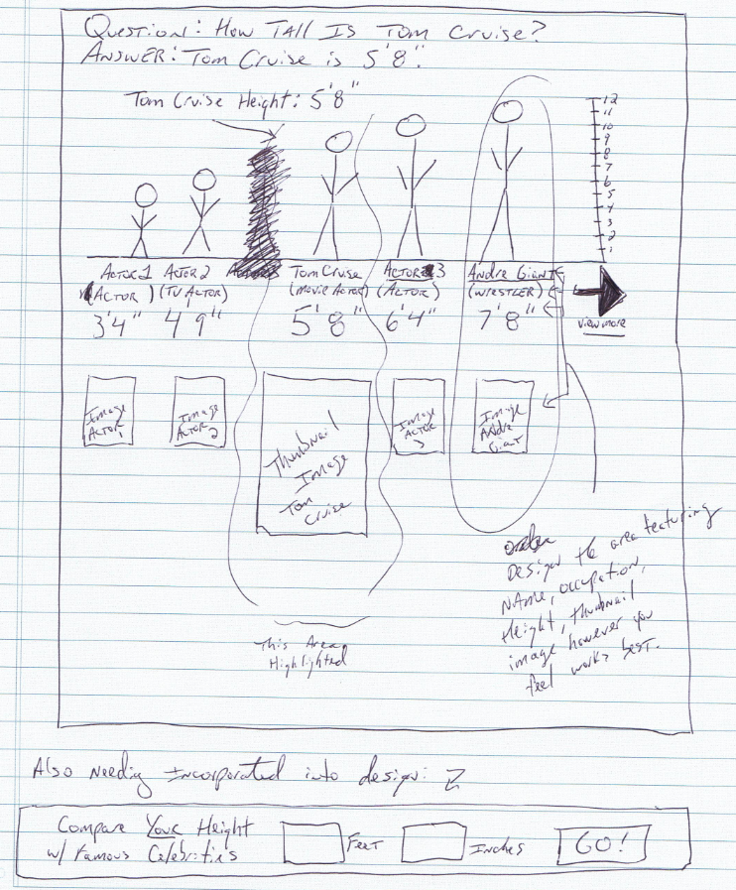
Below the stick people needs to display the content below… design however you see fit. Needs to highlight the person in the middle and the text needs to be designed to look how it will if it is .html You do not need to create the .html for this phase, but keep in mind, so your design reflects how it will look in .html.
  Katie Holmes  (Movie Actress)  Height: 5’ 2’’ | 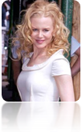  Nicole Kidman  (Movie Actress)  Height: 5’ 6’’ | 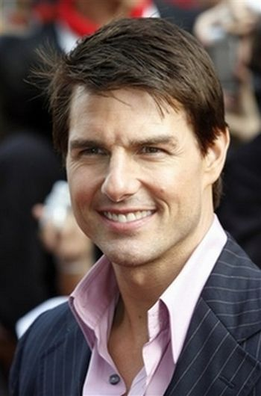  Tom Cruise  (Movie Actor)  Height: 5’ 8’’ | 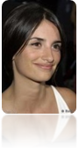  Penelope Cruz  (Movie Actress)  Height: 6’ 8’’ | 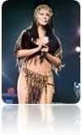  Cher  (Singer)  Height: 7’ 8’’

